School of Computer Science and Artificial Intelligence

Lab Assignment # 12.2

Program : B. Tech (CSE)
Specialization :AIML
Course Title : AI Assisted Coding
Course Code : 23CS002PC304
Semester : VI
Academic Session : 2025-2026
Name of Student : Nitesh Kumar
Enrollment No. : 2303A52098
Batch No. : 33
Date :24/02/26

Lab 12: Algorithms with AI Assistance – Sorting, Searching, and
Optimizing Algorithms
Lab Objectives:
• Apply AI-assisted programming to implement and optimize
sorting and searching algorithms.
• Compare different algorithms in terms of efficiency and use
cases.
Week6 -
Tuesday
• Understand how AI tools can suggest optimized code and
complexity improvements.
Task Description -1 (Data Structures – Stack Implementation with
AI Assistance)
➢ Task: Use AI assistance to generate a Python program that
implements a Stack data structure.
Instructions:
Prompt AI to create a Stack class with the following methods:
➢ push(element)
➢ pop()
➢ peek()
➢ is_empty()
➢ Ensure proper error handling for stack underflow.
➢ Ask AI to include clear docstrings for each method.
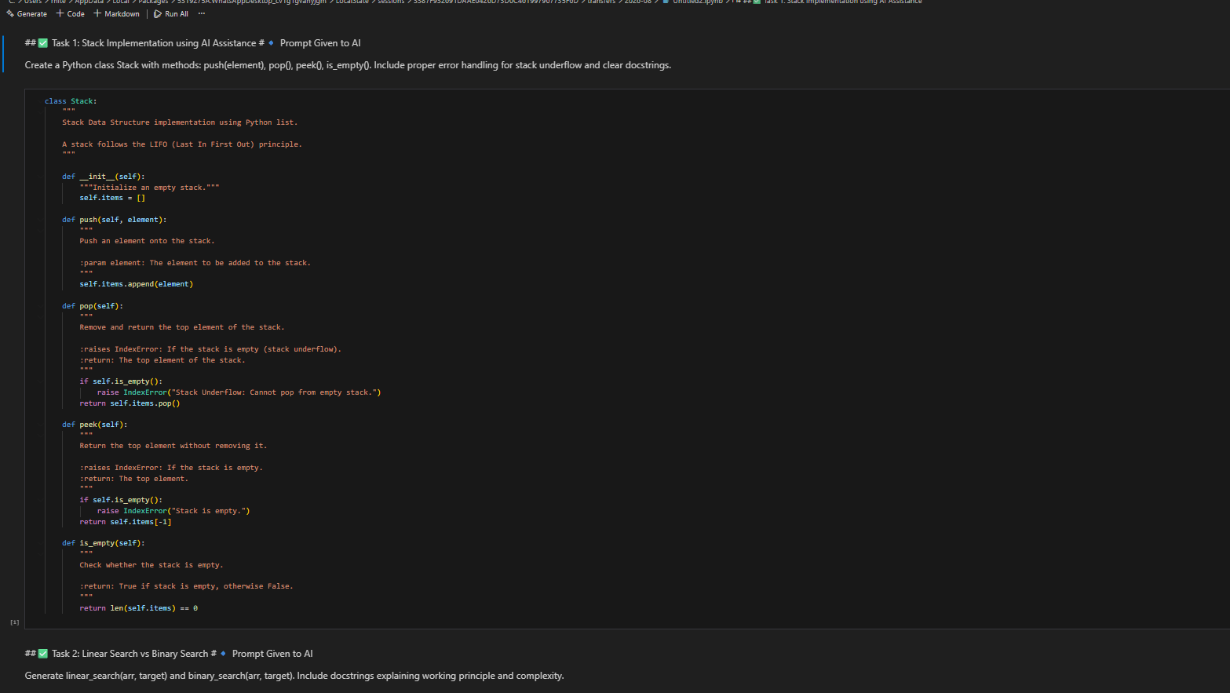
Task Description -2 (Algorithms – Linear vs Binary Search
Analysis)
➢ Task: Use AI to implement and compare Linear Search and
Binary Search algorithms in Python.
Instructions:
➢ Prompt AI to generate:
➢ linear_search(arr, target)
➢ binary_search(arr, target)
➢ Include docstrings explaining:
➢ Working principle
➢ Test both algorithms using different input sizes.
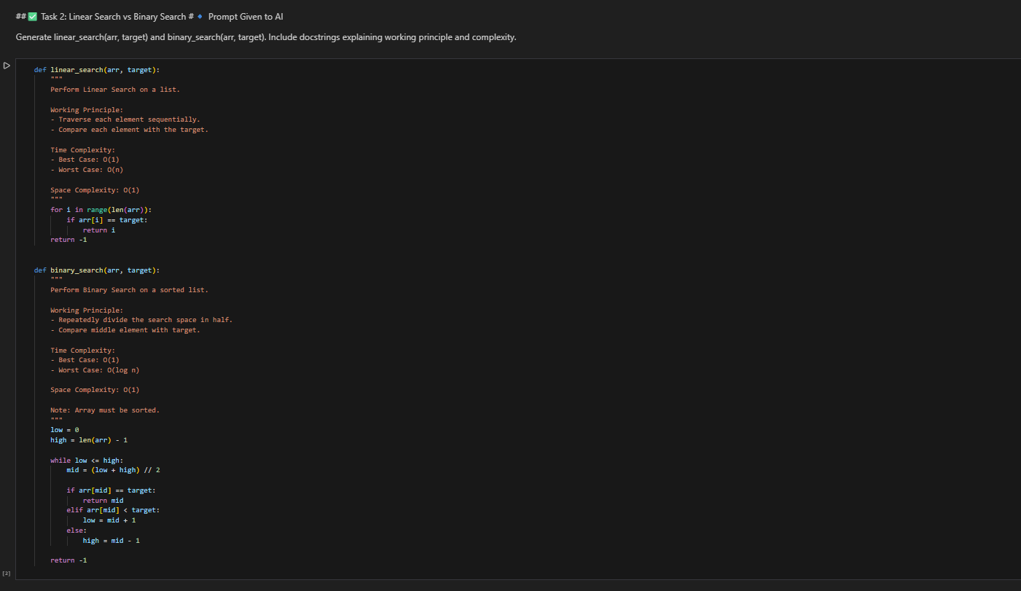
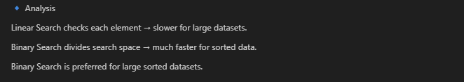
Task Description -3 (Test Driven Development – Simple Calculator
Function)
➢ Task:
Apply Test Driven Development (TDD) using AI assistance to
develop a calculator function.
Instructions:
➢ Prompt AI to first generate unit test cases for addition and
subtraction.
➢ Run the tests and observe failures.
➢ Ask AI to implement the calculator functions to pass all tests.
➢ Re-run the tests to confirm success.
Expected Output:
➢ Separate test file and implementation file.
➢ Test cases executed before implementation.
➢ Final implementation passing all test cases.
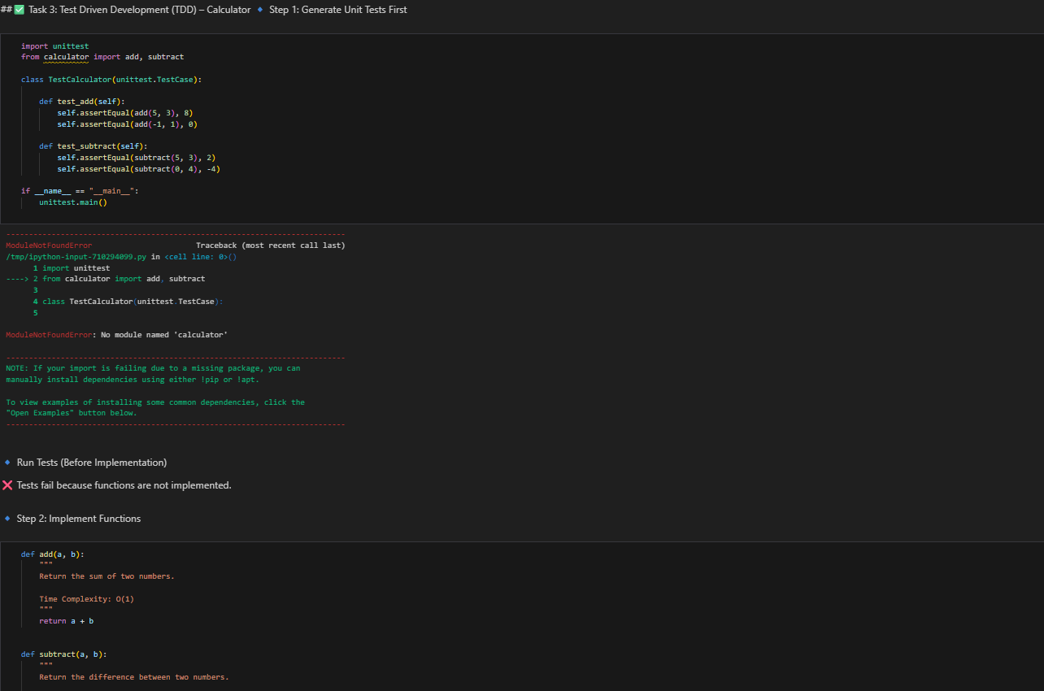
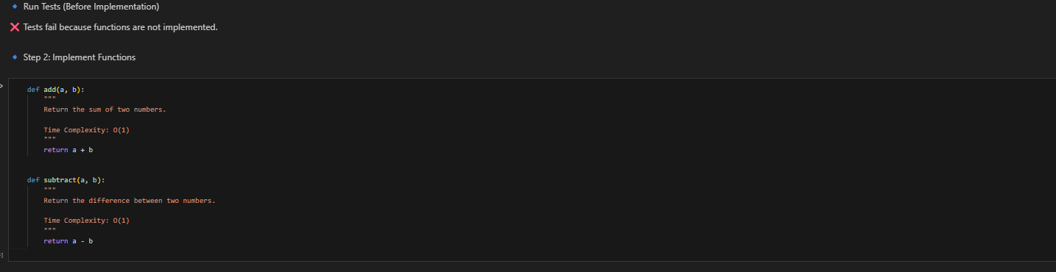
Task Description -4 (Data Structures – Queue Implementation with
AI Assistance)
➢ Task:
Use AI assistance to generate a Python program that implements
a Queue data structure.
Instructions:
➢ Prompt AI to create a Queue class with the following methods:
• enqueue(element)
• dequeue()
• front()
• is_empty()
➢ Handle queue overflow and underflow conditions.
➢ Include appropriate docstrings for all methods.
Expected Output:
➢ A fully functional Queue implementation in Python.
➢ Proper error handling and documentation.
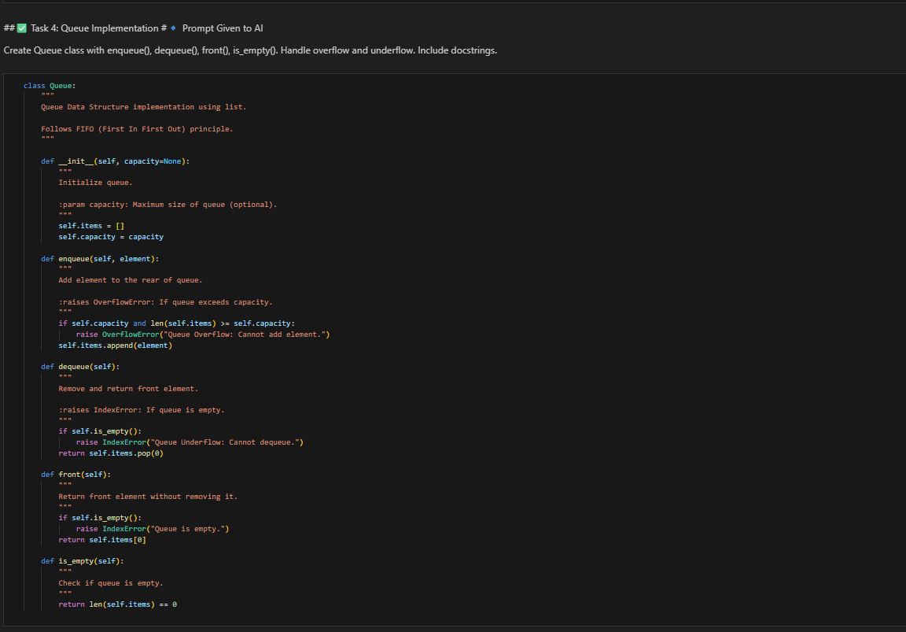

Task Description -5 (Algorithms – Bubble Sort vs Selection Sort)
➢ Task:
Use AI to implement Bubble Sort and Selection Sort algorithms
and compare their behavior.
Instructions:
➢ Prompt AI to generate:
• bubble_sort(arr)
• selection_sort(arr)
➢ Include comments explaining each step.
➢ Add docstrings mentioning time and space complexity.
Expected Output:
• Correct Python implementations of both sorting algorithms.
• Complexity analysis in docstrings.
